AWS TASK 2

Set up a VPC with an Internet gateway, create a public subnet with 256 IP addresses, a private subnet with 256 IP addresses, make a route table connecting the Internet gateway and the subnets, and launch a Linux EC2 instance by using the above VPC and public subnet.

Created VPC

Example created the IP range created in VPC 10.0.0.0/24 – 256 Ip address

Public Subnet 10.0.0.0/25 - 122 IPs
Private Subnet 10.0.1.128/25 - 122 IPs
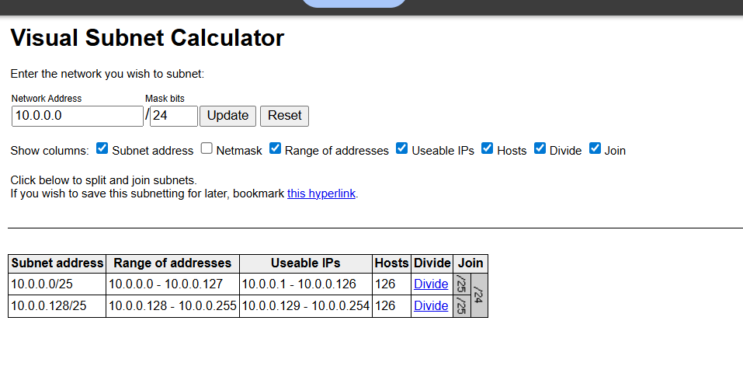

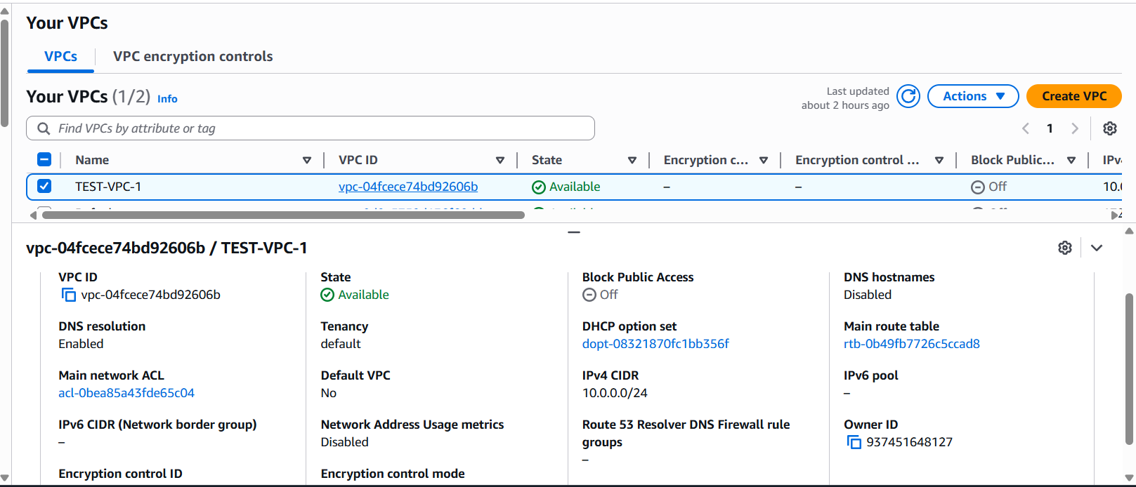
SUBNETS
Public Subnet
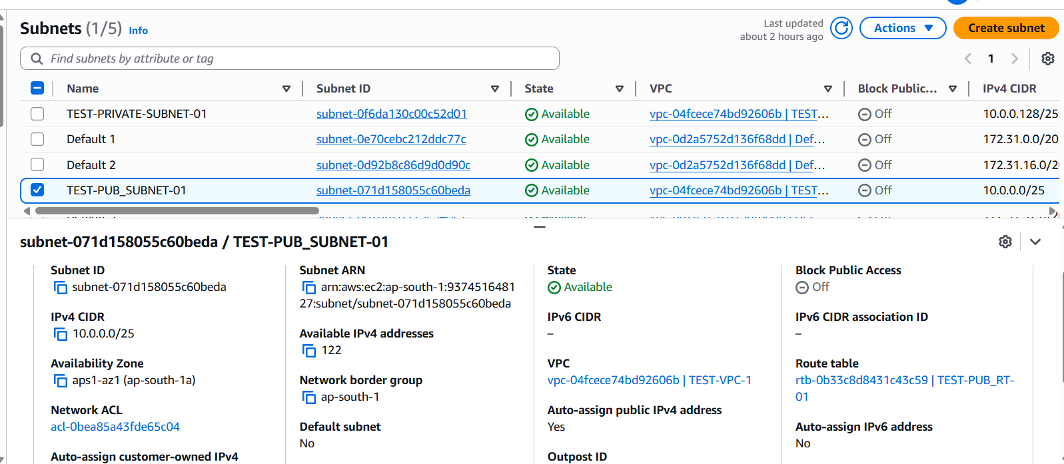

Private Subnet

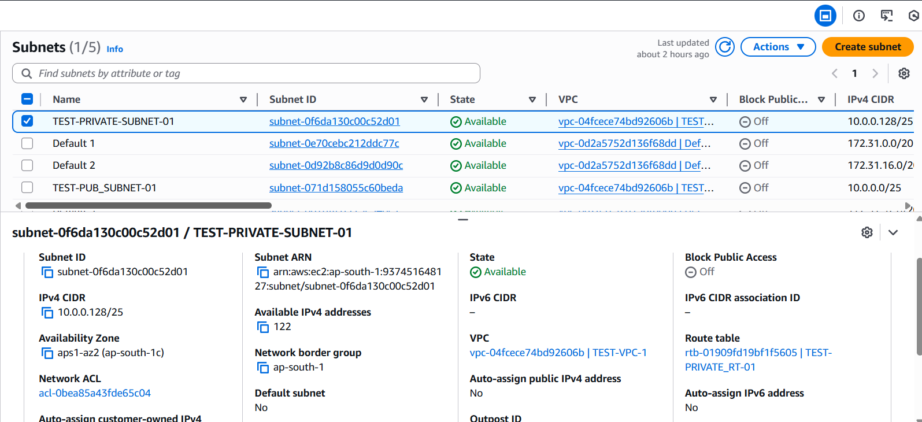

Route Tables

Public with IGW
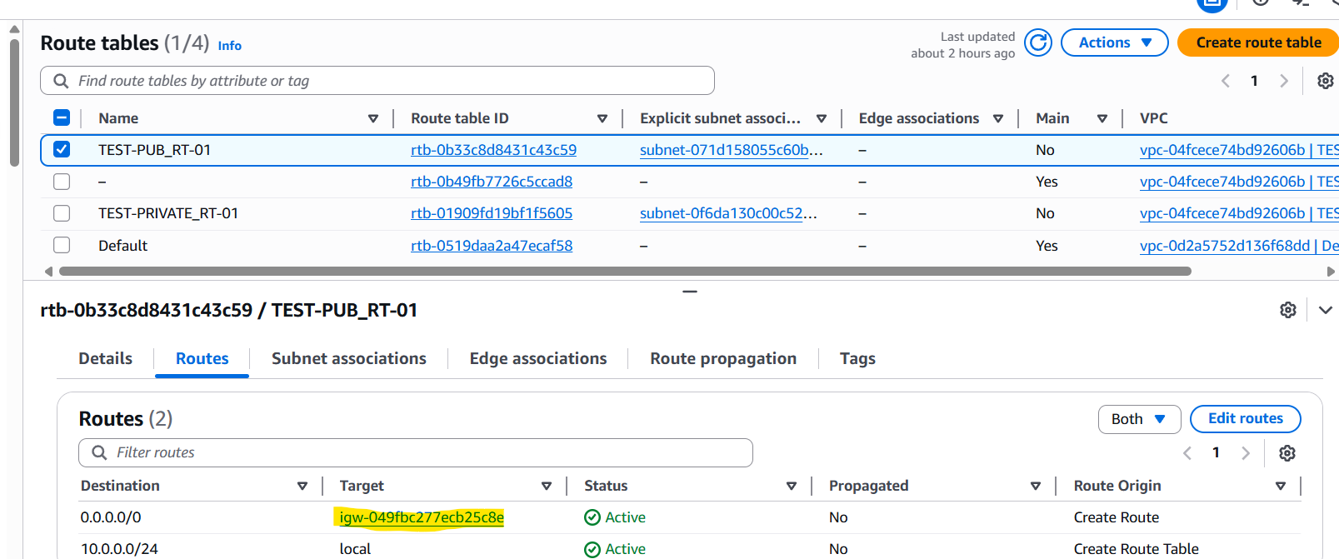

Private with NAT GW
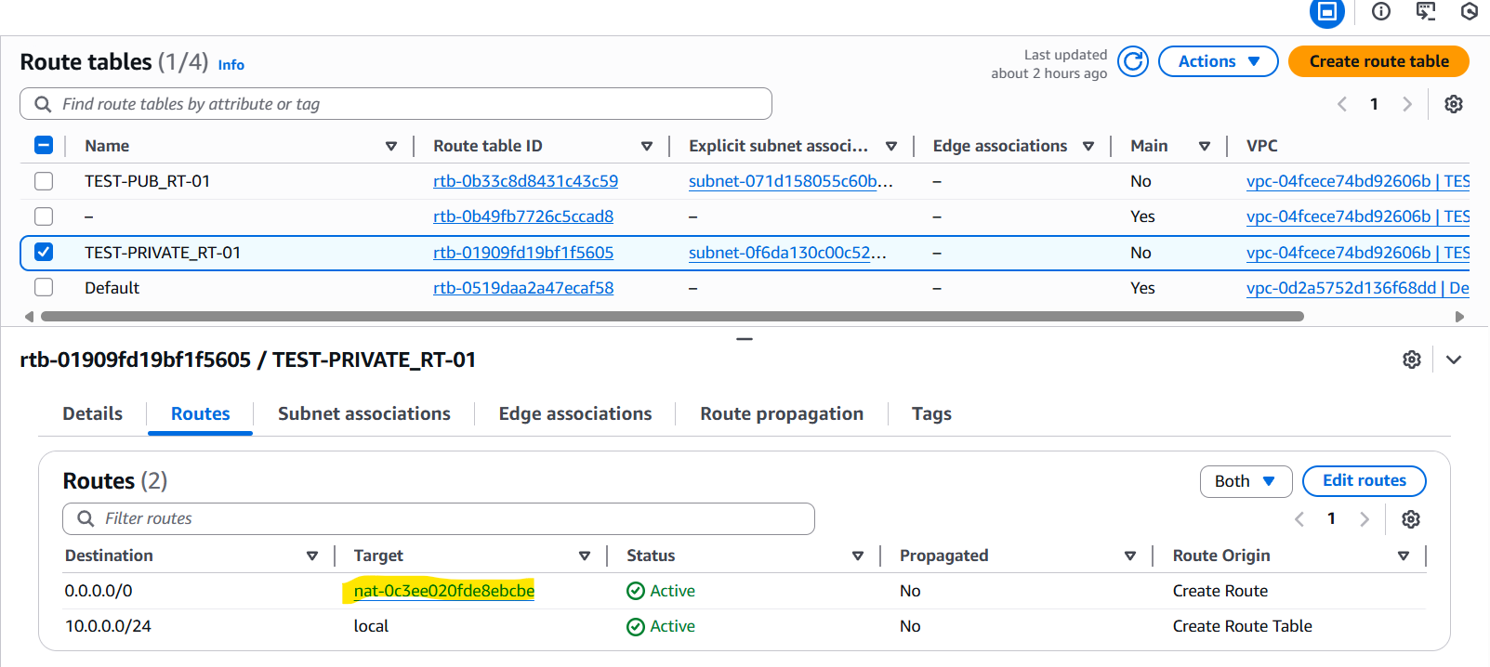

Server Access
Created 2 EC2
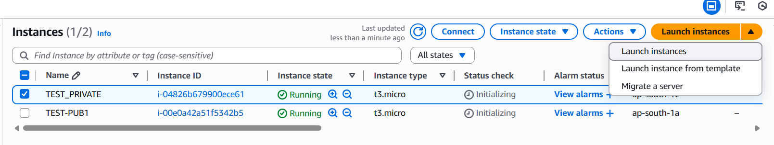

Public Server access:

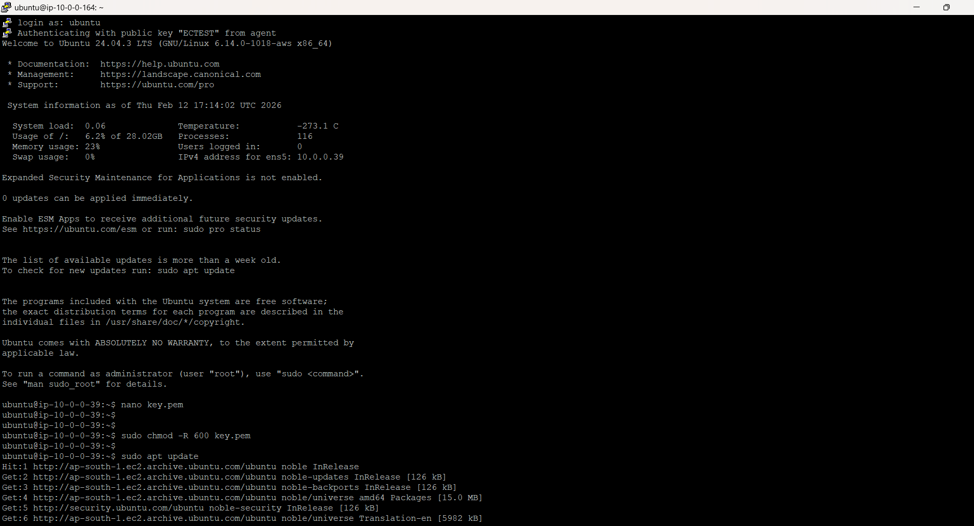

Private server with NAT:
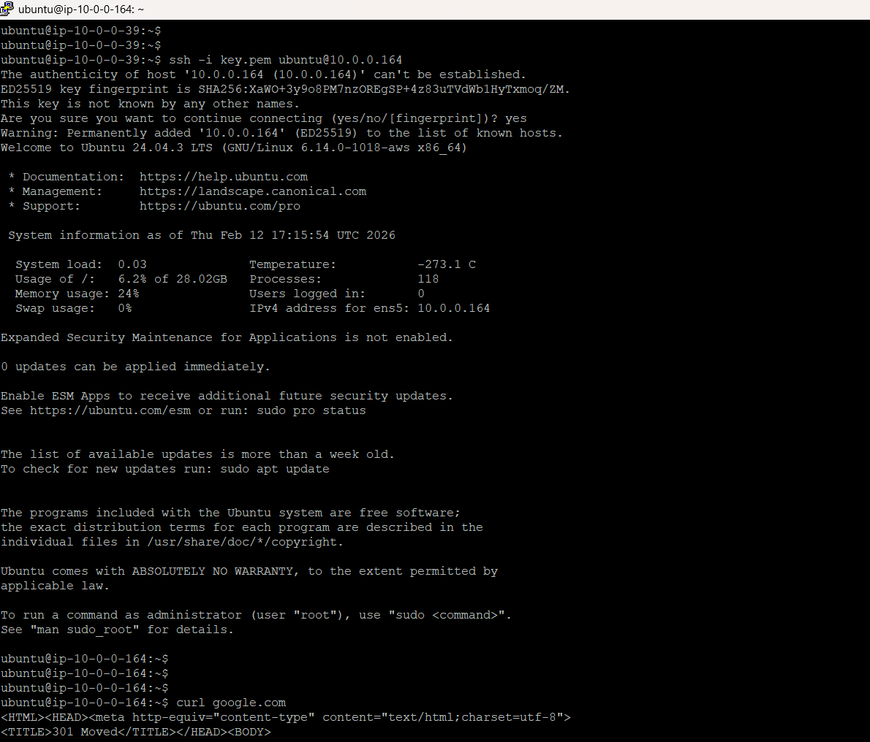

Private server Without NAT:
